Announcements
Our next council meeting will take place on Sunday, August 4th directly after Worship Service. Please plan to attend.

Our Charge Conference is scheduled to take place on Saturday, November 2nd, 2019 at 11:15 A.M. at the Wolcott UMC.
A Worship Service will take place prior to our meeting at 10:15 A.M.

The Farmer’s Market is taking place every
Wednesday between 2:30 and 6:00 P.M.
Please come out and support our local farmer’s
and our dedicated Market Team.

If possible, I would like to hold a brief Trustees Meeting directly after today’s service.

Leading this Morning’s Service:
Sermon: Pastor Bobbie Valentine
Pianist: Kayla Osika
Liturgist: Sandi Hamilton
Greeter: Bev Wing
Ushers: Bill Hall, Richard Ransley, Elayna Roscup, Brady McCarthy, Josh Roscup

MFA Carbone, Nicholas TAD/TDY USS Hawaii
C/O Pearl Harbor Mail Center 1025 Quincy Ave.
STE 700 JBPHH, HE 96860-4512

Jon-Anthony Carbone
2104 Red lion Rd.
Jacksonville, FL 32212

Gregory Coe
PSC 1005 Box 60, FPO AE
09593-0001

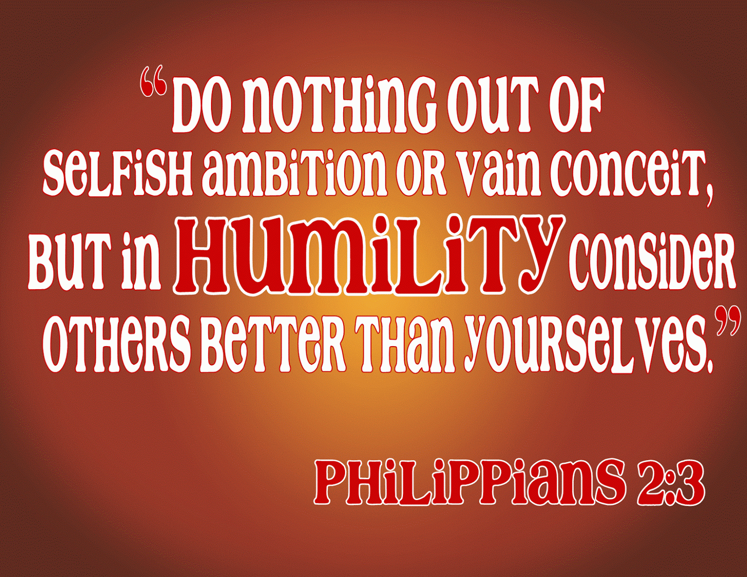

July 21, 2019
Pastor Bobbie Valentine
58 West Main Street
Sodus, New York 14551
Office: 315-483-9718
Parsonage: 315-553-2100
Pastor Bobbie: 315-406-9562
E-mail: utmc.sodus@yahoo.com
On line at: www.sutmc.org

The Mission of the Sodus United Third Methodist Church is to love, nurture, teach and stir into action all people by God’s love through Jesus Christ with the power of the Holy Spirit.

July 21, 2019
Prelude: Concerto No. 3 Mvmt. 2- J. S. Bach
Welcome!
Announcements
Bringing in the Light of Christ

*Call to Worship:
L: Come, all who are burdened with many tasks.
P: God provides a space for rest and renewal.
L: Come, all who have turned away from God.
P: God welcomes us with healing and forgiveness.
L: Come, all who desire to know Christ.
P: Here we find unexpected grace and unconditional love.
Thanks be to God!

*Opening Prayer: (in unison)
Creator God, we come from many places. Some of us come with heavy hearts. Some come with questions, some come with joy, some of us come with a long list of to do lists. Help us lay aside all that we carry with us and focus on you- the source of our lives, the one who fills our days with joy and love, the one who provides answers. Almighty God, we come this day to turn our minds and hearts toward you. In the name of Christ, we pray. Amen.

*Opening Hymn: He Touched Me # 367 UMH

Psalter, Psalm 2 vs 7-12 Responsive Reading:
L: I will tell of the decree of the Lord who said to me:
“You are my son, today I have begotten you.”
P: Ask of me, and I will make the nations your heritage,
and the ends of the earth your possession. You shall break
them with a rod of iron, and dash them in pieces like a potter’s vessel.
L: Now therefore, O kings, be wise; be warned, O rulers of the earth.
P: Serve the Lord with fear and trembling;
L: humble yourselves before the Lord lest
God be angry, and you perish in the way; For God’s wrath
is quickly kindled.
P: Blessed are those who take refuge in the Lord.

A Moment of Silent Prayer
Prayer offered by Pastor

SpiritFire
Come, Now Is The Time To Worship
I Love To Be In Your Presence

Prayers, Joys and Concerns
Offertory: Unfinished Symphony- F. Schubert
*Doxology
*Offertory Prayer: (in unison)
Faithful Redeemer, we offer these gifts to you. We give what we can. We ask that you bless and multiply our offerings. We also offer our very selves. Through our lives may people everywhere come to know the glory and wisdom we have found in Christ. In Your Holy Name, we pray. Amen.

SpiritFire
No Higher Calling

Old Testament Reading: Genesis 37: 8-20
New Testament Reading: Philippians 2: 1-5
This is the Word of God for the people of God.
Thanks Be to God.

*Hymn of Preparation: Make Me a Channel of Your Peace # 2171 FWS
Gospel Reading: Luke 10: 38-42
This is the word of God for the people of God.
Thanks Be to God.

Message: Given by Pastor Bobbie Valentine
*Closing Hymn: America 697
*Benediction
*Postlude: Largo- F. Chopin
*Signifies those who are able, please stand.

Joys and Concerns
July 17, 2019

Joys: Birth of our former Haitian student’s daughter on June 29 – Samuel Dorrelus and his wife’s first child. Birth of Roxanne’s sister’s premature baby, Crew.

Concerns:
Karen Buyck – Rehab at Wayne County Nursing and Rehabilitation Center following surgery for broken kneecap as a result of a fall.
Passing of our former pastor, Harry Stoll, on June 29th.
Pastor Dan Bradley’s family – death of Pastor Dan’s father, Robert on July 8.
Bailey Rae Dougherty – serious injuries from ATV accident resulting in death of her mother, Tammy Shaw. Prayers for the family.
Sandy (sister of Pastor Bobbie) – suffereing from vertigo.
Ray McCarthy – (Tammy Thiel’s father and Roy McCarthy’s uncle) Successful triple bypass surgery at Strong Memorial Hospital.
Roxanne Roscup’s sister -Julie Costantini - Premature birth of baby Crew at 29 weeks. Both baby and mom (Julie) are doing fine.
Rick LeRoy – Has MS – making good progress. At DeMay for rehabilitation.
Pauline Baker – rehab therapy after auto accident. Wayne County Nursing and Rehabilitation,1529 Nye Road, Lyons, NY 14489 Room 124
Betty Crocker – Hip rehab at Wayne County Nursing and Rehabilitation Center, 1529 Nye Road, Room 127B, Lyons, NY 14489
Henry Zerbe – Prayers for Henry and family – failing health issues.
Dan Hollebrandt – Still recuperating after stroke - 3924 Hall Center Road, Walworth, NY 14568

Sharon Maher – Making good progress after back surgery. 6578 Hunters Pt. Rd., N. Rose 14516
Sodus Point community - as they deal with high water.

Family Promise Program – program up and running. Continued prayers for the director, the many volunteers, and the success of this program.
World , friend and family struggles that are in our heart
The Hispanic Church; Main St ARC Home Residents/Staff
Military families who are separated by distance, but are close in their hearts .
Pastor Bobbie and Pastor Charlie Valentine

Prayers for our church … that we may continue to minister according to our mission: The Mission of the Sodus United Third Methodist Church is to love, nurture, teach and stir into action all people by God’s love through Jesus Christ with the power of the Holy Spirit.

James 1: 2 Consider it pure joy, my brothers and sisters,[a] whenever you face trials of many kinds, 3 because you know that the testing of your faith produces perseverance. 4 Let perseverance finish its work so that you may be mature and complete, not lacking anything.

