Announcements
Pastor Bobbie is on vacation beginning July 3rd – July 14th.
In case of an emergency please contact Pastor Darrell
Brown. Pastor Brown can be reached at 585-203-6286.

Leading this Morning’s Service:
Sermon: Bob Harvey
Pianist: Kayla Osika
Liturgist: Betty Mayou
Greeter:
Ushers: Bill Hall, Richard Ransley, Elayna Roscup, Brady McCarthy, Josh Roscup

MFA Carbone, Nicholas TAD/TDY USS Hawaii
C/O Pearl Harbor Mail Center 1025 Quincy Ave.
STE 700 JBPHH, HE 96860-4512

Jon-Anthony Carbone
2104 Red lion Rd.
Jacksonville, FL 32212

Gregory Coe
PSC 1005 Box 60, FPO AE
09593-0001

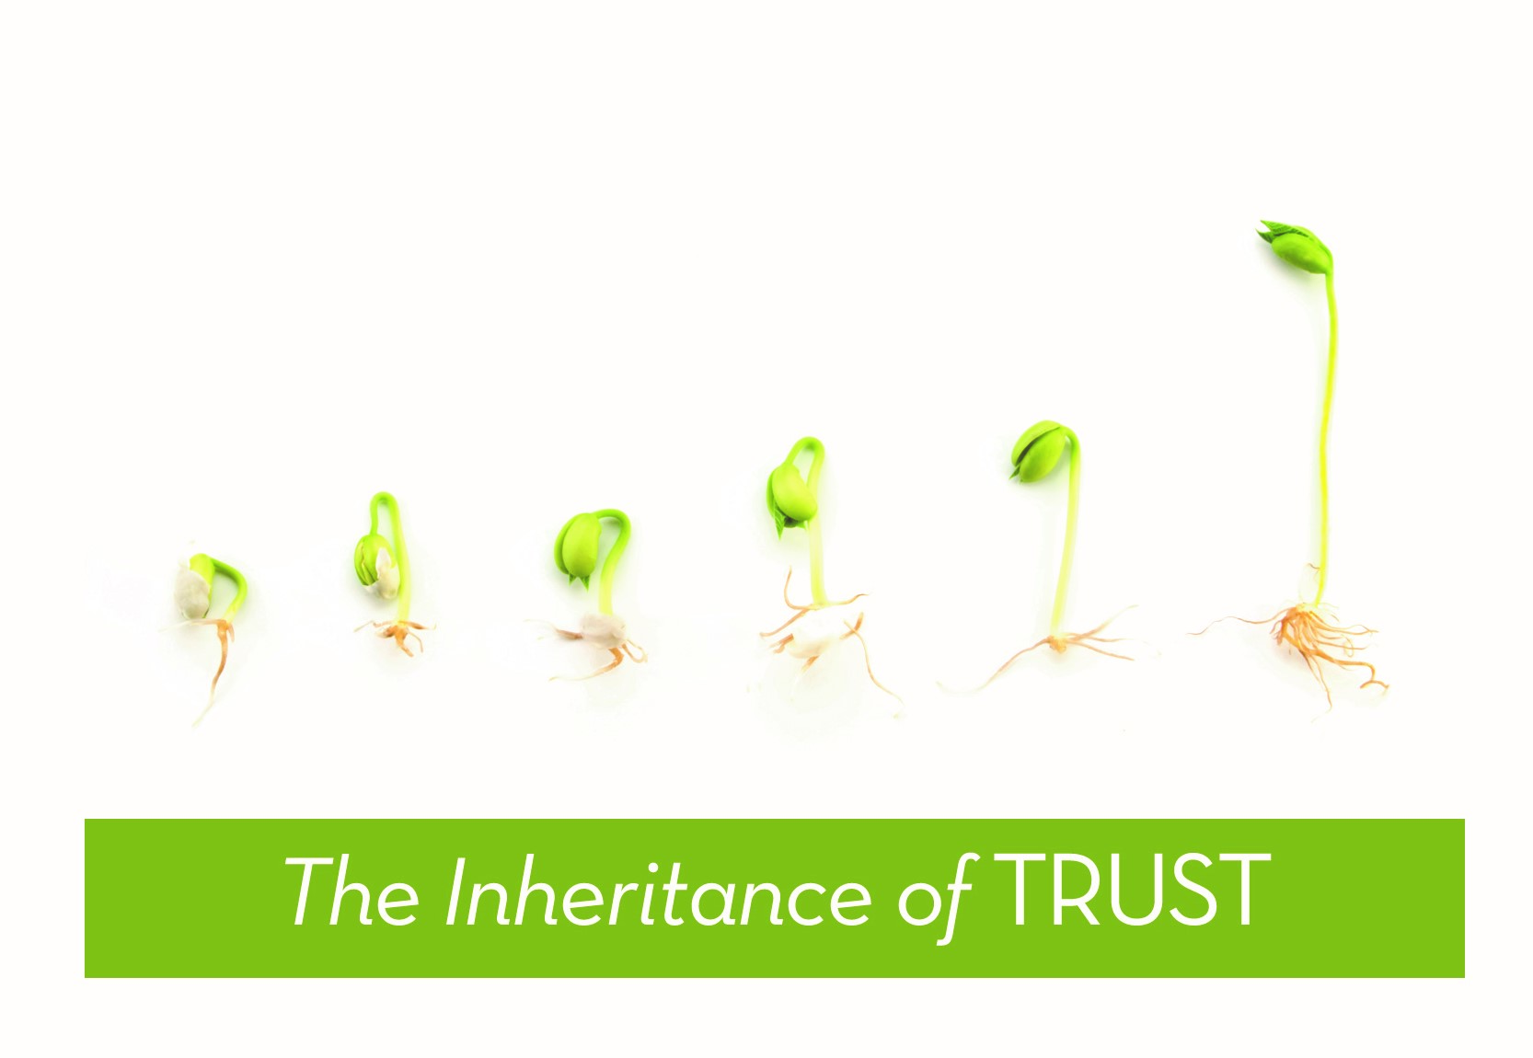

July 07, 2019
Pastor Bobbie Valentine
58 West Main Street
Sodus, New York 14551
Office: 315-483-9718
Parsonage: 315-553-2100
Pastor Bobbie: 315-406-9562
E-mail: utmc.sodus@yahoo.com
On line at: www.sutmc.org

The Mission of the Sodus United Third Methodist Church is to love, nurture, teach and stir into action all people by God’s love through Jesus Christ with the power of the Holy Spirit.

July 07, 2019

Prelude:
Welcome!
Announcements
Bringing in the Light of Christ

*Call to Worship:
I lift up your name, Lord
because you lifted me out of the muck.
You did not let work, worry, or weary steal my joy.
Lord I cried to you, and you healed me!
You lifted me up from the pit of death.
You restored my soul from the dark hole I had buried it in.
Join with me, sing praises to God, you faithful ones
Give thanks to the Lord
who turns our mourning into dancing for joy.
Praise the Lord, God, forever give thanks to the Lord!

*Opening Prayer: (in unison)
Thy word is a lamp unto my feet and a light unto my path. When I feel afraid, think I’ve lost my way, still you’re there right beside me. Nothing will I fear as long as you are near. Please be near me to the end. Thy word is a lamp unto my feet and a light unto my path. Amen.

*Opening Hymn: O God Our Help In Ages Past UMH 117

Nicene Creed UMH 880

SpiritFire
Remind Me Who I Am
There’s A Light

Prayers, Joys and Concerns
Offertory:
*Doxology

*Offertory Prayer: (in unison)
Creator and Architect of the Universe, the gifts we bring to your altar this day are but a small part of the inheritance you have provided us. Your steadfast love has never failed us, yet too quickly we forget; we worry about scarcity; we fret about uncertain times and claim our trust is in you, but our living and giving often tell a different story. Remind us, Lord, of our inheritance; help us to grow in our trust of you and your providence and your wisdom in knowing what we really need for abundant life. In Christ, we pray. Amen.

SpiritFire: “Still”

Old Testament Reading: 2 Kings 5: 1-14
New Testament Reading: Galatians 6: 7-10

This is the Word of God for the people of God.
Thanks Be to God.

*Hymn of Preparation: “Trust and Obey” UMH 467

Gospel Reading: Luke 10: 1-11, 16-20

This is the word of God for the people of God.
Thanks Be to God.

Message: The Inheritance of Trust

*Closing Hymn:“God Will Take Care of You” UMH 130

*Benediction

*Postlude:

*Signifies those who are able, please stand.

Joys and Concerns
July 1, 2019
Joys: Birth of Roxanne’s sister’s premature baby, Crew. We welcome Sophie DuBois to Spiritfire! Sophie is a talented guitarist (and has a beautiful voice)! Congratulations to Gloria Mayou who was named by a Senior as most influential teacher!
Health Concerns: Sandy (Pastor Bobbie’s sister), Ray McCarthy, Roxanne’s sister ( Julie Costantini), Rick LeRoy, David Meneely, Joan Carter, Bob Herman, Carol Conley, Boone Leuwen, Kathy Wren, John Cropper, Sharon Maher, Dan Hollebrandt, Henry Zerbe, Betty Crocker, Roxanne Roscup’s mom’s cousin, Bob, Pauline Baker.
Sandy (sister of Pastor Bobbie) – suffereing from vertigo.
Ray McCarthy – (Tammy Thiel’s father and Roy McCarthy’s uncle)Successful triple bypass surgery at Strong Memorial Hospital.
Roxanne Roscup’s sister -Julie Costantini - Premature birth of baby Crew at 29 weeks. Both baby and mom (Julie) are doing fine.
Rick LeRoy – Has MS – making good progress. At DeMay for rehabilitation.
Pauline Baker – rehab therapy after auto accident. Wayne County Nursing and Rehabilitation,1529 Nye Road, Lyons, NY 14489 Room 124
Roxanne Roscup’s mom’s cousin, Bob – Long recovery ahead after surgery.
Betty Crocker – Hip rehab at Wayne County Nursing and Rehabilitation Center, 1529 Nye Road, Room 127B, Lyons, NY 14489
Henry Zerbe – Prayers for Henry and family – failing health issues.
Dan Hollebrandt – Still recuperating after stroke - 3924 Hall Center Road, Walworth, NY 14568

Sharon Maher – Making good progress after back surgery. 6578 Hunters Pt. Rd., N. Rose 14516
Sodus Point community - as they deal with high water.
Family Promise Program – program up and running. Continued prayers for the director, the many volunteers, and the success of this program.
World , friend and family struggles that are in our heart
The Hispanic Church; Main St ARC Home Residents/Staff
Military families who are separated by distance, but are close in their hearts .
Pastor Bobbie and Pastor Charlie Valentine
Prayers for our church … that we may continue to minister according to our mission: The Mission of the Sodus United Third Methodist Church is to love, nurture, teach and stir into action all people by God’s love through Jesus Christ with the power of the Holy Spirit.
Psalm 16: ⁸ I keep my eyes always on the Lord. With him at my right hand, I will not be shaken.

