Announcements
Please be sure to visit the church’s website: www. sutmc.org for beautiful musical arrangements each week.

Please remember our military families.

MFA Carbone, Nicholas TAD/TDY USS Hawaii
C/O Pearl Harbor Mail Center 1025 Quincy Ave.
STE 700 JBPHH, HE 96860-4512

Jon-Anthony Carbone
2104 Red lion Rd.
Jacksonville, FL 32212

Gregory Coe
PSC 1005 Box 60, FPO AE
09593-0001

August 9th, 2020
Sharing Our Faith

SODUS UNITED THIRD METHODIST CHURCH
Pastor Bobbie Valentine
58 West Main Street
Sodus, New York 14551
Office: 315-483-9718
Parsonage: 315-553-2100
Pastor Bobbie- 315-406-9562
E-mail: utmc.sodus@yahoo.com
On line at: www.sutmc.org

The Mission of the Sodus United Third Methodist Church is to love, nurture, teach and stir into action all people by God’s love through Jesus Christ with the power of the Holy Spirit.

August 9th, 2020
Welcome
Announcements

Joys and Concerns
Pastoral Prayer
The Lord’s Prayer

Tithes and Offerings
Doxology
Offertory Prayer offered by Pastor

Instrumental music offered by Nick Thurston

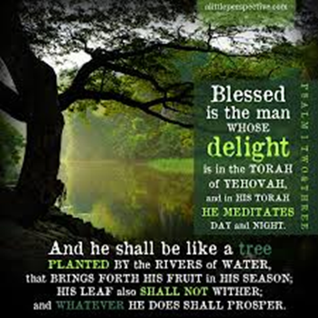

Psalm 1 Responsive Reading
L: Blessed are those who do not walk in the counsel of the wicked;
P: or stand in the way of sinners, or sit in the seat of scoffers;

L: but their delight is in the law of the Lord,
P: and on God’s law they meditate day and night.
L: They are like trees planted by streams of water that yield their fruit in season, and their leaves do not wither.
P: In all that they do, they prosper.

ALL: Walk in the light of God’s counsel, delight in the law of the Lord.

L: The wicked are not so, but are like chaff which the wind drives it away.
P: Therefore, the wicked will not stand in judgement; nor sinners in the congregations of the righteous;
L. for the Lord knows the way of the righteous,
P: but the way of the wicked will perish.

ALL: Walk in the light of God’s counsel, delight in the law of the Lord.

Prayer for Illumination (In unison)
Almighty God, in a world of change you placed eternity in our hearts and gave us the power to discern good from evil. Grant us sincerity, that we may persistently seek the things that endure, refusing those which perish, and that, amid things vanishing and receptive, we may see the truth steadily, follow the light faithfully, and grow ever richer in that love which is the life of all people; through Jesus Christ our Savior. Amen.

Guest Speaker- Steve

Prayer offered by Pastor

Instrumental music offered by Nick Thurston

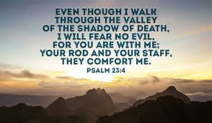

Psalm 23 Responsive Reading
L: The Lord is my shepherd; I shall not want.
P: The Lord makes me lie down in green pastures,
L: leads me beside still waters, restores my life,
P: leads me in right paths for the sake of the Lord’s name.
L: Yea, though I walk through the valley of the shadow of death, I will fear no evil;
P: for thou art with me; thy rod and staff they comfort me.

ALL: The Good Shepherd comes that we may have life and have it abundantly.

L: You prepare a table before me in the presence of my enemies;
P: you anoint my head with oil, my cup overflows.

L: Surely goodness and mercy shall follow me all the days of my life,
L: and I shall dwell in the house of the Lord as long as I live.

ALL: The Good Shepherd comes that we may have life and have it abundantly.

Guest Speaker- Maureen

Prayer offered by Pastor
Benediction

Instrumental music offered by Nick Thurston

Joys and Concerns for the Week of August 3rd.
Prayers

For all school personnel as they prepare for school openings across New York State.

For all college personnel, and college students as they begin the Fall 2020 semester.

For the people of Beirut who are coping with the recent explosion.

Dorothy Beh- (Donna Hontz’s mom)- Dorothy’s health has improved, please continue to keep her in prayer.

John Faulks and families as he fights cancer.

Daryl Minier – Daryl is at home and feeling better. He continues to monitor his diet and is slowly introducing more foods.

Alonzo Davis- Please keep Alonzo in your prayers. He is home but being monitored closely.

Beth Bouwens who continues to move forward with her treatment for breast cancer.

Chris Kimball Peterson- Certified Lay Servant- member of the Finger Lakes District Lay Servant team, member of the Trumansburg United Methodist Church. Chris needs prayers again as she and her family have decided to stop chemo treatments and are hopeful that her health will improve.

Jackie and Roy Truswell. Jackie is a Certified Lay Leader and has provided pulpit supply for Sodus Third and other churches in the Finger Lakes District. Roy, her husband broke his back and is in intensive care. Jackie requests prayers for her husband, and for her own emotional and physical strength.

Elderly couples- Dick and Nancy Ransley, Wayne and Donna Stickler, (Pastor Bobbie’s sister and brother-in-law), and John and Barb Pettingill (from the Aloquin Church), who have underlying health issues which keep them at home. Wayne Stickler is now in rehab after falling and fracturing two vertebrae.

For all those who have been injured or killed by gun violence and social unrest.

For our policemen and women who work toward keeping us safe in legal and righteous ways.

The Upper New York Conference, the Finger Lakes District, and the Sodus United Third Methodist Church.

Matthew 14:13-14- When Jesus heard about John, he withdrew in a boat to a deserted place by himself. When the crowds learned this, they followed him on foot from the cities. When Jesus arrived and saw a large crowd, he had compassion for them and healed those who were sick.

